7.10: (a) The flea leaves the ground with an upward velocity of 1.3 m/s and then is in free-fall with acceleration 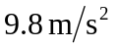 downward. The maximum height it reaches is therefore 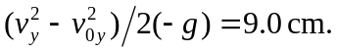 The distance it travels in the first 1.25 ms can be ignored.
(b)
